Department of Artificial Intelligence

And Data Science





**MISRIMAL NAVAJEE MUNOTH JAIN ENGINEERING COLLEGE**

OWNED AND MANAGED BY TAMILNADU EDUCATIONAL AND MEDICAL FOUNDATION

A Jain Minority Institution

Approved by AICTE &Programmes Accredited by NBA, New Delhi, (UG Programmes – MECH, AI&DS, ECE, CSE,IT)

All Programmes Recognized by the Government of Tamil Nadu and Affiliated to Anna University, Chennai

Guru MarudharKesari Building, Jyothi Nagar, Rajiv Gandhi Salai, OMR Thoraipakkam, Chennai - 600 097.

|  |  |  |  |  |  |  |  |  |  |  |  |  |
| --- | --- | --- | --- | --- | --- | --- | --- | --- | --- | --- | --- | --- |
| **Register No:** |  |  |  |  |  |  |  |  |  |  |  |  |

**BONAFIDE CERTIFICATE**

This is to certify that this is a bonafide record of the work done by

**_______________________________** of IV Year / VII Semester

**B. TECH- ARTIFICIAL INTELLIGENCE AND DATA SCIENCE** for the

**NM1042-MERN Stack powered by MongoDB Laboratory**

during the Academic year 2024-2025.

**Faculty-in-charge Head of the Department**

**Submitted for the University Practical Examination held on :**

**Internal Examiner External Examiner**

**DATE: DATE:**

**Index**

|  |  |
| --- | --- |
| **Topic** | **Pg No.** |
| Introduction | 5 |
| Case Study | 6 |
| **Scenario-Based Case Study** | 7 |
| **Pre-requisites** | 8 |
| Application Flow | 9 |
| Proof Of Work | 13 |
| Future Enhancement | 19 |

**Introduction**

The **Online Learning Platform (OLP)** is a cutting-edge web application designed to revolutionize digital education. Built using the MERN stack (MongoDB, Express.js, React.js, Node.js), this platform provides an all-in-one solution for students, teachers, and administrators to engage in seamless and interactive online learning experiences.

Education in the 21st century demands adaptability and technological integration, and OLP serves as the bridge between learners and educators by enabling effective management of courses, real-time communication, and progress tracking. With its robust architecture and intuitive interface, OLP ensures that learners from diverse backgrounds can access quality education anytime, anywhere.

The project addresses the challenges of traditional education, such as limited accessibility, lack of personalization, and logistical hurdles, by leveraging modern technologies. Its user-centric features, such as role-based dashboards, discussion forums, live webinars, and automated certification, create an ecosystem that caters to the needs of both students and educators.

With the ever-increasing demand for digital education, OLP aims to democratize learning by providing a scalable, secure, and engaging platform that can be accessed across devices. This report highlights the platform's architecture, features, user roles, case studies, known issues, and potential enhancements for the future.

**Case Study**

The **Online Learning Platform (OLP)** has proven to be a versatile solution for various user groups, including students, teachers, and administrators. Let us delve into the platform's real-world applications through the following examples:

**Case Study 1: Personalized Learning for Students**

John, a software engineer working full-time, wants to upskill by learning Python programming. He registers on the OLP and finds a Python programming course. The course includes recorded lectures, live webinars, quizzes, and downloadable resources. John tracks his learning progress, engages with peers in the discussion forums, and clarifies doubts with the instructor during live sessions.

By the end of the course, John completes a final assessment and earns a digital certificate, which he showcases on his LinkedIn profile. OLP empowers John to learn at his own pace while balancing his professional commitments.

**Case Study 2: Streamlined Teaching Experience for Educators**

Lisa, a university professor, uses OLP to create and manage her online courses. She uploads lecture materials, schedules live webinars, and tracks her students' progress. Lisa also uses the discussion forum to interact with her students, answer queries, and provide personalized feedback.

The platform's analytics dashboard helps Lisa identify struggling students and provide additional support, enhancing her teaching effectiveness. With OLP, Lisa efficiently bridges the gap between traditional teaching methods and modern digital tools.

**Case Study 3: Efficient Administration**

Ravi, an admin, oversees platform operations, including managing user accounts, approving new course listings, and resolving technical issues. OLP's admin dashboard provides Ravi with detailed insights into platform performance, user engagement, and system health. This enables him to monitor and optimize the platform for a seamless user experience.

## ****Scenario-Based Case Study****

### ****Scenario 1: Dynamic Role-Based Access Control****

**Example:**

* Priya is a student who can enroll in courses, participate in discussions, and earn certificates.
* Meena, her teacher, can create course content, conduct live webinars, and review students' progress.
* Ravi, the admin, oversees the platform's operation, ensuring smooth performance and resolving any issues.

This dynamic multi-role system simplifies platform management while ensuring a personalized experience for each user role.

### ****Scenario 2: Real-Time Collaboration****

**Example:**

* Arjun, a student, posts a query in a Python programming forum. Within minutes, he receives replies from both his peers and the instructor, fostering a collaborative learning environment.

The discussion forum becomes a powerful tool for knowledge sharing, quick query resolution, and community building.

## ****Prerequisites****

To develop and run the **Online Learning Platform**, the following prerequisites are essential:

### ****System Requirements****

* **Node.js** (v14 or higher): A runtime environment for executing JavaScript on the server side.  
  [Download Node.js](https://nodejs.org/)
* **MongoDB**: A NoSQL database for storing and managing application data.  
  [Download MongoDB](https://www.mongodb.com/try/download/community)
* **React.js**: A library for building dynamic and responsive user interfaces.  
  [React Installation Guide](https://reactjs.org/docs/create-a-new-react-app.html)
* **Git**: Version control system for managing the source code repository.  
  [Download Git](https://git-scm.com/downloads)

**Application Flow**

The **Online Learning Platform (OLP)** is meticulously designed to guide users through a structured and intuitive learning journey, ensuring a seamless experience for students, teachers, and administrators. The platform's application flow is centered around user engagement, accessibility, and functionality.

For **students**, the journey begins with account creation and login through a secure authentication system powered by JSON Web Tokens (JWT). Once logged in, students can explore a catalog of courses presented in a well-organized and visually appealing interface. These courses are categorized by subject, difficulty, and instructor, helping students easily locate the most relevant content. Upon selecting a course, students can view detailed information, including course objectives, instructor details, and content outlines. They can enroll with a single click and start accessing lectures, quizzes, and other materials.

Interactive learning is a core feature of the application flow. Students can participate in live webinars hosted by instructors, join discussion forums to interact with peers, and access real-time chat for instant doubt resolution. To track progress, the platform provides detailed insights into completed modules, upcoming tasks, and performance in assessments. On successful course completion, students receive digital certificates that they can showcase in their professional profiles.

For **teachers**, the application flow is tailored to enable effortless course creation and management. After logging in, teachers access a dashboard where they can upload lectures, create quizzes, schedule webinars, and monitor student performance. Teachers can use forums and chat functionalities to provide guidance and resolve queries, ensuring active engagement with students.

**Admins** oversee the platform's functionality, ensuring smooth operation and addressing any user issues. Their flow involves monitoring course listings, managing user accounts, and generating system reports. They have the tools to intervene if necessary, such as approving or rejecting course submissions and resolving complaints.

Key steps in the application flow include:

1. **User Authentication:** Secure login and registration processes for all roles.
2. **Course Browsing and Enrollment:** Comprehensive course catalogs with filters for easy navigation.
3. **Interactive Features:** Real-time webinars, discussion forums, and progress tracking for enriched learning.
4. **Certification:** Automated issuance of certificates post-completion.
5. **Admin Oversight:** Robust control panel for managing users, courses, and platform analytics.

This streamlined flow ensures that every user interacts with the platform efficiently, enhancing satisfaction and usability.

**Project Flow**

The project flow outlines the entire operational architecture of the **Online Learning Platform**, emphasizing the interaction between frontend, backend, and database layers. Each phase of the flow is meticulously designed to ensure reliability, scalability, and a user-friendly experience.

The process begins when a user accesses the platform, either as a student, teacher, or admin. The **frontend** is built using React.js, which dynamically renders the user interface based on the user's role. For instance, students see course catalogs and progress trackers, teachers access course management tools, and admins view the dashboard for overseeing platform operations.

When a user interacts with the platform, such as enrolling in a course or uploading course materials, the **frontend** sends an API request to the **backend**, which is powered by Node.js and Express.js. The backend processes these requests, handles business logic, and interacts with the **database layer**. MongoDB, the chosen database, stores critical information such as user data, course details, and progress records.

For example, if a student adds a course to their list, the frontend sends this action as a POST request to the backend. The backend validates the request, updates the database using Mongoose, and sends a response back to the frontend. This flow ensures smooth, real-time updates for users.

Administrators benefit from a custom-built control panel that allows them to manage system operations. They can monitor user activity, generate reports, update course listings, and resolve technical issues efficiently.

Key phases in the project flow:

1. **Frontend Rendering:** React.js dynamically adjusts the interface based on user roles, ensuring a personalized experience.
2. **API Communication:** Axios facilitates seamless interaction between the frontend and backend.
3. **Backend Logic:** Node.js and Express.js manage requests, perform business operations, and validate inputs.
4. **Database Operations:** MongoDB stores user profiles, course data, progress reports, and payment details.
5. **Admin Functions:** A dedicated admin panel provides oversight of all platform activities.

By dividing responsibilities across these layers, the project ensures robust performance, efficient resource utilization, and a scalable framework capable of supporting future growth.

**Proof Of Work**

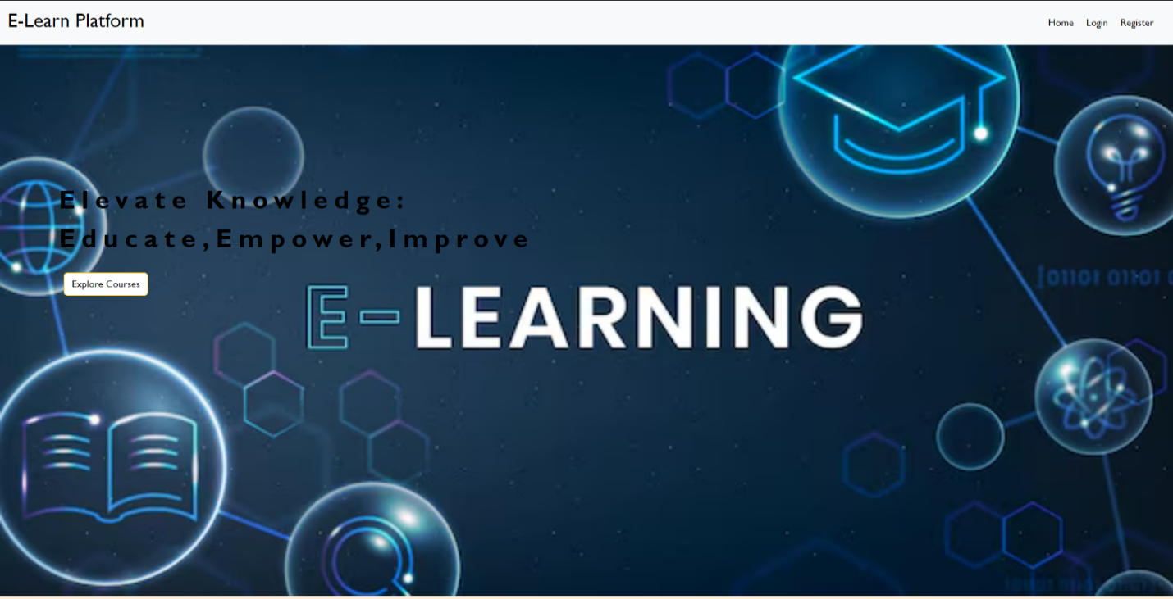**Home Page:**

**SIGN-IN Page:**

**SIGN-UP Page:**

**Student Dashboard:**

**Course View:**

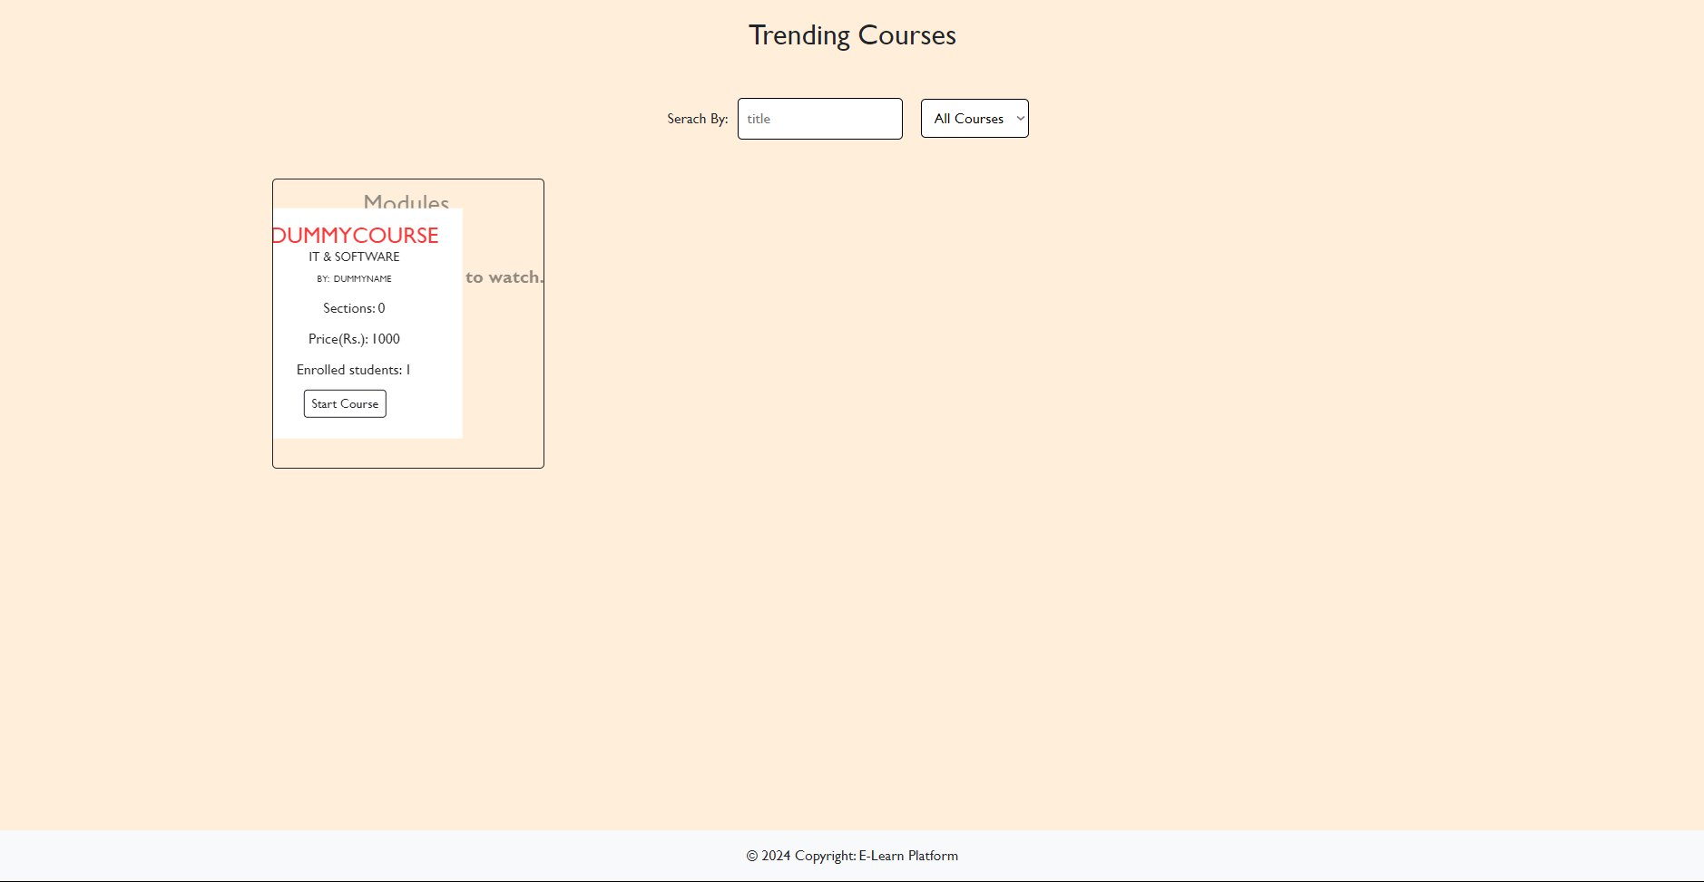

**Payment(Enrollment Page):**

**Certification Download Page:**

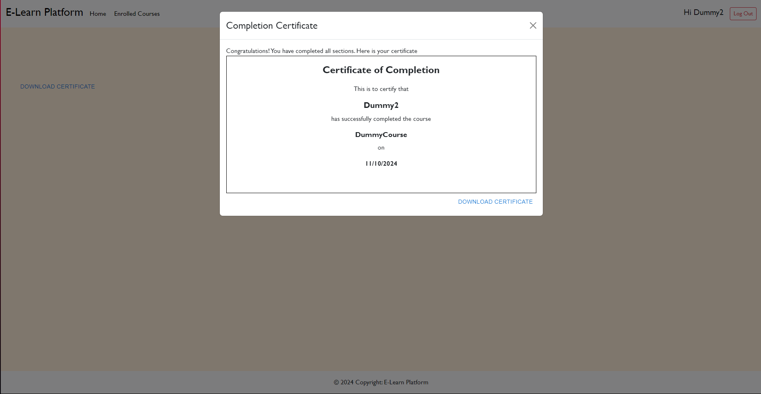

**Course Enrolled :**

**Teacher Dashboard:**

**Course Creation Page:**

**Teacher Dashboard:**

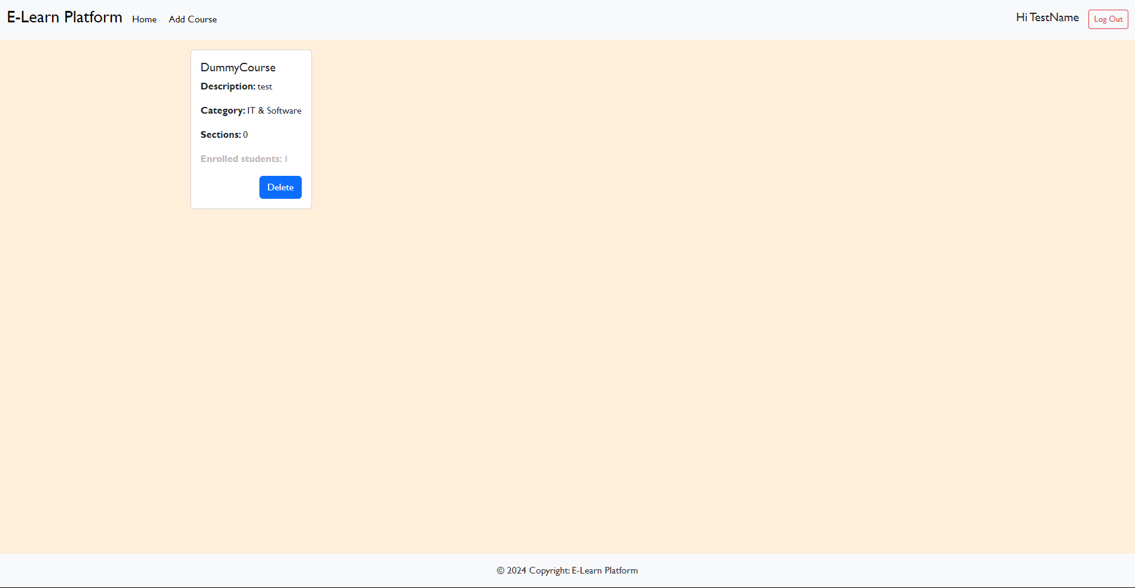

**Admin Dashboard:**

**Future Enhancements**

The Online Learning Platform has already established a strong foundation; however, several enhancements are planned to elevate its functionality and broaden its reach. These improvements focus on user engagement, accessibility, and scalability to ensure the platform remains competitive in the fast-evolving ed-tech space.

1. **Real-Time Notifications**  
   To keep users informed, the platform will implement real-time notifications. These alerts will update students about new courses, upcoming webinars, forum replies, and certification availability. Notifications will be delivered via email, push notifications, and an in-app notification center, ensuring users never miss critical updates.
2. **AI-Powered Recommendations**  
   The platform will integrate machine learning algorithms to analyze user behavior, course history, and preferences. This data will be used to recommend personalized learning paths, making it easier for students to find relevant courses and maximize their learning potential.
3. **Offline Access**  
   For learners in areas with limited connectivity, the platform will offer offline access. Students will be able to download course materials, videos, and quizzes for offline viewing, with progress syncing back to the system once they regain internet access.
4. **Advanced Search Filters**  
   The search functionality will be enhanced with advanced filters, including price range, difficulty levels, instructor ratings, and course duration. These features will make it easier for students to navigate an expanding course catalog.
5. **Multi-Language Support**  
   As the platform aims to expand globally, adding support for multiple languages will be critical. Courses, navigation menus, and instructions will be available in several languages, broadening the platform's accessibility to diverse user bases.
6. **Guest Checkout Option**  
   To simplify the enrollment process, a guest checkout option will be introduced. This will allow students to enroll in courses without creating an account, reducing friction for first-time users and casual learners.
7. **Mobile Applications**  
   Native mobile applications for Android and iOS will be developed to enhance accessibility. These apps will include offline support, push notifications, and optimized layouts for small screens, making learning on the go more convenient.
8. **Subscription Services**  
   A subscription model will be introduced, offering users access to exclusive courses, personalized coaching, and priority customer support. Subscription plans will cater to individuals, corporates, and educational institutions, increasing user engagement and revenue streams.
9. **Admin Dashboard Enhancements**  
   To empower administrators, the dashboard will be upgraded with advanced analytics and reporting tools. These enhancements will provide insights into user behavior, course performance, and financial metrics, enabling data-driven decision-making.
10. **Gamification Features**  
    To boost engagement, the platform will incorporate gamification elements like badges, leaderboards, and streak tracking. These features will encourage users to remain active and complete courses.

These future enhancements aim to make the Online Learning Platform a leader in the ed-tech industry by offering innovative solutions, improved accessibility, and superior user experience.